Sponsor/
Partial supporter/
Co-organizer
Track No | Logo | Description & URL
Track 1-3 |  | University of Hyderabad, India  http://www.uohyd.ernet.in
Track 1-4 | Get logo from url | University of Petra, Jordan  http://www.uop.edu.jo
Track 2-2 | 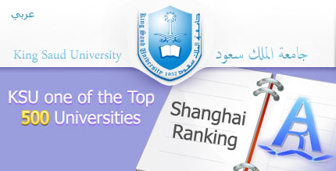 | King Saud University,Saudi Arabia  http://www.ksu.edu.sa
Track 2-3 |  | GSB Life Sciences  http://ebabe.gsblifesciences.org
Track 2-6 | Get logo from url | Pharmaceutics International, Inc, USA  http://www.pharm-int.com/
Track 3-1 |  | Dr. Tanay Waingankar, Life Science Industry Marketing Manager, Agilent Technologies  Life Science & Chemical Analysis Division, G01, Andheri (E), Mumbai, India.
Track 3-4 | Get good logo from URL | Boys Town National Research Hospital, USA
Track 4-4 | Get logo from URL  Dr. Rajendra S Pradhan, Director, Clinical Pharmacokinetics and Pharmacodynamics, Clinical Pharmacology and Pharmacometrics, Abbott labs, Abbott Park, IL, USA. | Abbott Laboratories  http://www.abbott.com/

