Encyclopedia of BioAvailability and BioEquivalence (E-BABE) for Studies of Pharmaceuticals
Srinubabu Gedela, Ranganath Gudimella, Shobha Lingam, Swetha Mandha,
Anusha Gundu
GSB life sciences, Tarnaka, Hyderbad-500017, India.

Abstract:
E-BABE is a unique encyclopedia involving bioanalytical methods for bioavailability and bioequivalence studies of pharmaceuticals. E-BABE is first open source application powered by bioanalytical methods of pharmaceuticals for suitable method selection with thousands of combinations and searches against these methods. It’s a bibliographic repository containing bio-analysis methods of drugs classified on their activities with in different sites in human or model organisms. Most scrutinized literature was collected from PUBMED using drugs and different chromatographic methods as queries, and collection is based on updated, determined and biological sample involved within the literature. This literature is used to extract important fields like conditions and preparations from chromatographic methods basing on the drug to build a database. Database includes drug based bioanalytical methods covering most required fields and external database links of important drug portals. Search/querying the database is through drug name, chemical formula or structural search by smiles format. Most sophisticated repository for pharmaceutics working with biological samples and it was build understanding the needs of the pharmacy and labs working on bioanalytical chromatographic methods. Keen selections of bio analytical methods for pharmaceutical analysis or regular quality control are also possible with E-BABE. A future aviation would be to develop an analytical methodology database with more features for availability and needs of scientific and industrial communities.

Introduction:

Clinical influence of the drugs is estimated through clinical trails to elute the pharmacokinetic and pharmacodynamic behavior to ensure safety and efficacy of the drugs. While pharmacokinetics are the most applied pharmaceutical methods to describe the bioavailability and bioequivalence studies. Bioequivalence (BE) describes the showing same in vivo nature with other reference product but statistically different when administered in same molar dosages and Bioavailability (BA) is rate of availability of the administered drug within the systemic circulation. There are in vivo and in vitro types of studies in bioequivalence are more prevalent during clinical trails, there are some characteristic features to be investigated drug evaluation of the drugs in the biological matrix like half life of drugs, activity in case of prodrugs and limitation of the analyte.
Hence there is a need for quantitative evaluation of the drugs and their metabolites are important for assessing the biopharmaceutical nature for clinical studies. This need is fulfilled by bioanalytical validation by various chromatographic estimations of the drugs from biological matrices like blood, serum, plasma and urine. While the fundamental parameters involved for validation are precision, accuracy, selectivity, sensitivity, reproducibility and stability. Validation involves the total documentation of the drug for a laboratory can be performed with various types like full, partial and cross validations depending upon the availability of studies on particular drug. A standard procedure must be followed during the process of bioanalytical methods such as reference standard preparation, bioanalytical method development and application of validated bioanalytical method to drug analysis and analytical run or batch run. To amalgamate process of validation bioanalytical methods are simplified into two stages such as pre-study phase and study phase where pre phase involves validation in biological samples and study phase focuses on bioavailability and bioequivalence to satisfy fundamental parameters.
Bioanalytical methods applied for BE and BA studies are gas chromatography (GC), high pressure liquid chromatography (HPLC) , combined GC and LC mass spectrometry(MS) for biological matrices . These methods development and establishment include determination of (a) Selectivity (b) accuracy, precision, recovery
(c) Calibration curve (d) Stability of analyte in samples
(a) Selectivity is ability of a method to differentiate and quantify the analyte in the presence of biological matrix (plasma, urine etc.) which is obtained from six sources as per FDA (Food and Drug Administration, USA) guidelines. These samples should be tested for inference and selectivity by Lower Limit of Quantification (LLOQ).
(b) Accuracy of a method describes the mean of test results obtained by concentration of the analyte which is measured by using at least five determinations per concentration.
Precision of a method describes individual measure of an analyte when the procedure is applied repeatedly and it is also measured by using minimum of five determinations per concentration.
Recovery of an analyte in an assay is detected amount of analyte added to and extracted from the biological matrix and it is performed by comparing the results of extracted samples at low, medium and high concentrations with unextracted samples to represent 100% recovery.
(c) A calibration curve or standard curve is the relation ship between instrument response and known concentration of the analyte which is prepared in the same biological matrix as the samples in the intended study by spiking the matrix with know concentrations of the analyte.
(d) Drug stability in a biological fluid is a function of the storage conditions, the chemical properties of the drug, the matrix and the container system.

Materials and Methods:

E-BABE, itself defined as encyclopedia of drug based bioanalytical methodologies and bibliographic database. So, the primary concern is making a list of drugs both generic and branded drugs from various sources. Collecting literature of each and every drug containing its HPLC and LCMS analysis, large amount of literature/articles are scrutinized to extract the exact points needful for BA and BE studies.
To make data more accessible and informative bioinformatics approach was utilized to annotate the extracted data with programming and database management. Finally an online application with most sophisticated features which would make E-BABE more reachable database for most pharmaceutical and research labs.

To build E-BABE a series of steps were followed they are

- Collection of list of drugs based on classification
- Collection of Literature from PUBMED Journal
- Extraction of methods from drug based articles
- Curation of the extracted data
- Building E-BABE database based on methods.

Collection of list of drugs based on classification

Drugs are listed from updated databases of FDA, Merck manual and PDR (Physician’s Desk Reference).Books of pharmacology and therapeutics are also involved in building list of most available drugs. Over 1200 drugs from different classification were collected from the available resources. Drugs are classified based on various drug acting sites like central nervous system, therapy of inflammation, renal and cardiovascular function, chemotherapy (Microbial, parasitic, neoplastic diseases).

Collection of Literature from PUBMED Journal

Bidirectional querying in bibliographic database PubMed gave more miscellaneous hits, so various criteria’s were applied for filtering the hits to get more accurate articles. Those include LCMS and HPLC based articles along with other methods, bioanalytical methods with human and animal samples, only methods from 1995 to 2009 where given preference, single or simultaneous drug determinations, drug with analysis of its metabolites and its quantitations. Stanford library access was used in collecting full texts and various bibliographic tools made collection process faster and accurate.

Extraction of methods from drug based articles

Fields describes the complete process of bioanalytical validation during pharmacokinetics, describing the selectivity, accuracy, precision and recovery points in each method of chemical assay. Results of each method were described by involving Lower limit of quantification (LLOQ), Limit of detections (LOD) and Linearity Range (LR). To unleash all the steps involved during bioanalytical validation some fields were extracted from each articles of drug, those are classification of the drug, sample preparation, internal standard, standard preparation, instrumentation (LCMS/HPLC),chromatographic conditions, detection / fragmentation, recovery, LOQ/Linearity Range (LR) and cmax,
tmax values.

Curation of the extracted data:
To link E-BABE with latest updates and advanced information tried to curate with external database links like Physician’s Desk Reference (PDR),US-Food and Drug Administration (FDA), Merck manual, Rxlist. Some bioinformatics resources like KEGG Drug, KEGG Compound, Pubchem Compound, Pubchem Substance and drug bank are involved for each and every method to get drug properties, assays and drug target sites along with its gene and protein information at single method page in E-BABE. Finally concluded with detection and recovery of the drug in the given method and trying to provide necessary information for regular bioequivalence studies.

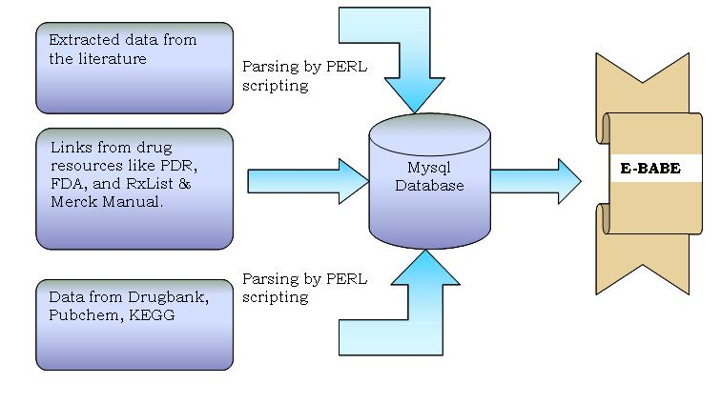
Figure 1: Computational method applied for data mining for E-BABE.

Building E-BABE database based on methods:
Converting data into XML and making XML based schema for handling large amount of data and adding AJAX technologies for querying against the database such as xquery and xpath. Easy accessibility with providing flexible environment with PHP front end designing and brow sable pages for each bioanalytical method embedded based on the drugs. Providing download in PDF format for each method is a feature of distribution of knowledge.

Conclusions:
Based on collected data sets HPLC and LCMS are most prevailing methods in BA/BE studies. It provides solutions for generating drug based reports during pharmacokinetics. Methods studied in E-BABE may be applied for both generic and branded drugs and would be a gateway for making drug development process faster. It fulfills the most of the requirements in regular bioequivalence and bioavailability studies by providing key information of bioanalytical methodologies.More advancements in pharmacy research to be encouraged to make the drug development process faster.

Advantages:
- Drug name based encyclopedia with more data in flexible formatting
- Target customers are pharmaceutical companies , commercial laboratories and research labs and non profit organizations.
- Promoting a new fields in the pharmacy research computationally
- Making available around 5000 drug based bioanalytical methods at a single repositories.

Database is available at http://gsb.omicsonline.info/

